SSH INTO USER WITHOUT ANY “PASSWORD” OR “.PEM FILE”
- Login to your ec2-user using “putty” or “instance connect”.
- Generate SSH Keys ~ “ssh-keygen -t rsa -b 4096 ”
Output ~
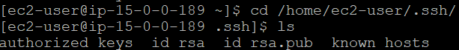
- Add a new user “Vaishnavi” ~ “sudo useradd vaishnavi”
- Make “Home directory for that user” ~ “sudo mkdir /home/vaishnavi”
- Assign the ownership of the directory to the user ~ “sudo chown vaishnavi:vaishnavi /home/vaishnavi”
- Set permissions ~ “sudo chmod 755 /home/vaishnavi”
- Create .ssh directory for Vaishnavi ~ “sudo mkdir -p /home/vaishnavi/.ssh”
- Change Ownership ~ “sudo chown vaishnavi:vaishnavi /home/vaishnavi/.ssh”
- Set permissions ~ “sudo chmod 700 /home/vaishnavi/.ssh”
- Append the public key using cat ~ “sudo sh -c "cat /home/ec2-user/.ssh/id_rsa.pub >> /home/vaishnavi/.ssh/authorized_keys" ”
- SSH into your Vaishnavi user ~ “ssh vaishnavi@13.233.186.116”
Output ~
